Parth Babbar

Personal Loan Origination and Servicing, Auto Loan Origination and Servicing, and Mortgage Loan Origination and Servicing in the US

Personal Loan Origination and Servicing:
Personal loans play an important role in consumer finance since they provide funding for a variety of objectives, including debt reduction, home upgrades, and unforeseen needs. These loans can be secured (backed by collateral such as a car or savings account) or unsecured (based only on the borrower's creditworthiness), and the interest rates are generally set or variable.
Origination Process:
- Application and Underwriting: Borrowers submit loan applications that include financial information, job history, and how they intend to spend the cash. Lenders examine applicants' creditworthiness by analysing credit records, confirming income, and calculating debt-to-income ratios. The underwriting procedure subsequently determines if the loan is accepted, as well as the precise parameters such as interest rates, payback durations, and loan amount.
- Loan Approval and Disbursement: Once loans have been authorized, borrowers complete the procedure by consenting to the conditions and signing loan agreements. Disbursement techniques usually include sending payments straight to the borrower's bank account. Borrowers are then advised of their repayment schedules and the particular terms they agreed upon. This provides transparency and responsibility throughout the lending process.
Servicing Process:
- Loan Repayment: Borrowers make monthly payments on agreed-upon conditions, covering both interest and principal amounts. Borrowers have the option of making payments electronically, with automated withdrawals, or with manual checks. Lenders often provide choices such as refinancing or loan modification to assist clients handle financial fluctuations more successfully. These alternatives might change terms such as interest rates or repayment schedules to better suit the borrower's needs.
- Customer Service and Support: Lenders provide comprehensive customer service, supporting borrowers with queries, repayment issues, and account administration. Borrowers facing financial troubles might look into forbearance or hardship programs, which offer temporary reprieve from loan payments or amended repayment schedules to assist them get through challenging times.
Challenges:
- High default rates in certain borrower categories represent a major risk, necessitating stringent risk management techniques.
- Regulatory compliance requirements establish tight restrictions that lenders must follow to ensure legal and ethical standards are upheld.
- Managing these problems entails taking proactive steps to reduce losses and maintain stability in lending operations.
Solutions:
- Enhanced Credit Scoring Models: Using sophisticated credit scoring models enhances accuracy in analysing borrower risk and decision-making procedures for loan approvals.
- Personalized Loan Offerings: By tailoring loan alternatives to borrower profiles, lenders may provide more appropriate terms and conditions that address individual financial needs and capabilities.
- Integrating Digital Tools: Using digital tools simplifies loan management operations, providing borrowers with simple alternatives for application, tracking, and repayment, hence improving customer experience and operational efficiency.
Statistics:
- Average Personal Loan Amount: The average personal loan in the United States is around $16,259.
- Interest Rate Trends: Personal loan interest rates can vary greatly, although they normally range between 6% and 36% APR, depending on the borrower's creditworthiness.
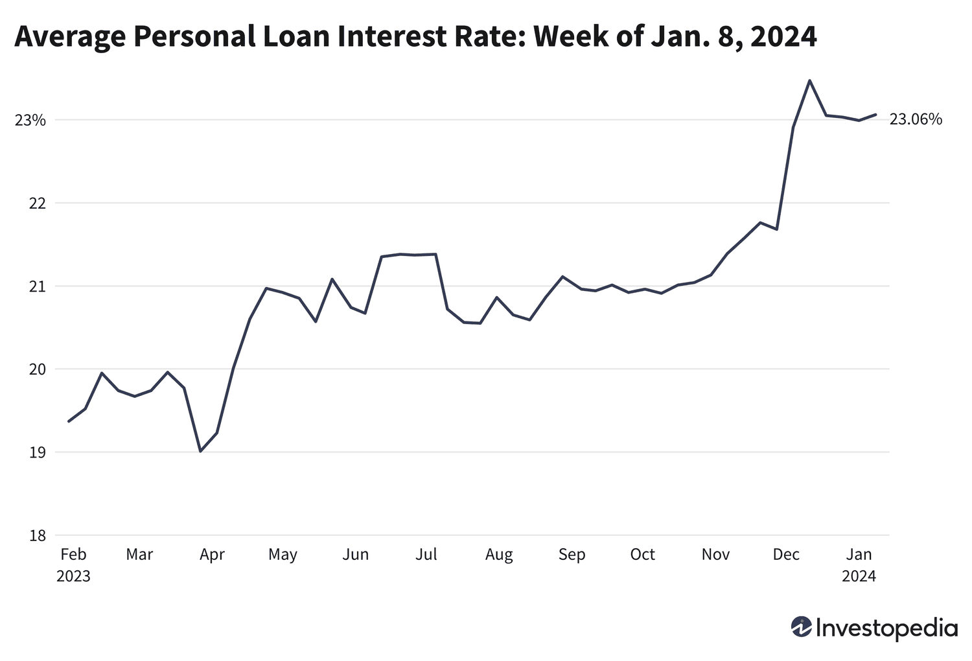
- Default Rates: According to current data, the default rate for personal loans is around 3.57%.
- Delinquency Statistics: Approximately 3.22% of personal loans are more than 30 days late.
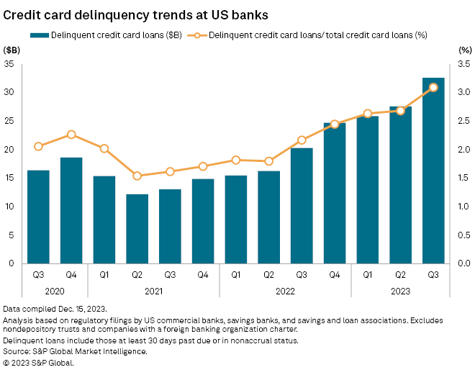
Conclusion:
Personal loans are an important part of consumer finance since they provide people with the finances they need for a variety of personal reasons. The origination procedure, which includes extensive credit evaluation and underwriting, ensures that loans are suited to the borrower's financial situation. To effectively service these loans, strong customer assistance and flexible repayment choices must be available to accommodate borrowers' shifting financial situations. Despite the problems of high default rates and regulatory compliance, financial institutions may improve their loan offers by implementing innovative credit scoring models and digital management systems, resulting in better borrower experiences and lower risks.
Auto Loan Origination and Servicing:
Auto loans promote vehicle purchases by offering borrowers finance choices such as direct lending or dealership financing. These loans are secured by the vehicle and often carry fixed or variable interest rates dependent on creditworthiness.
Origination Process:
- Application and Approval: Borrowers apply for loans by submitting car selections and financial information. Lenders consider credit ratings, income stability, and debt-to-income ratios when approving loans. The terms, including interest rates and payback durations, are then negotiated to meet both parties' financial requirements and risk tolerance.
- Loan Funding and Purchase: Funding alternatives usually include a direct transfer of monies to the seller or dealership financing agreements. After loan agreements are concluded, borrowers utilize disbursed cash to acquire automobiles, completing the deal.
Servicing Process:
- Repayment and Management: Monthly payments cover principle and interest, with automated or manual options available. Borrowers can refinance to change the payments or conditions as needed. Lenders manage automobile ownership transfers and lien releases upon loan repayment.
- Customer Support: Lenders give assistance with loan queries, account management, and troubleshooting to guarantee a positive borrower experience. In the event of default or nonpayment, lenders handle repossession procedures to alleviate delinquency and limit financial risks.
Challenges:
- Economic Downturns and Repayment: Economic downturns can diminish borrower income and stability, making it more difficult to repay loan commitments and raising default risk.
- Managing Loans from several Lenders: Managing loans from several lenders increases complexity, requiring borrowers to track payments, handle varying conditions, and make timely repayments to avoid penalties or defaults.
Solutions:
- Flexible Repayment Options: Lenders provide customisable repayment plans based on individual borrower circumstances, making loan administration easier and increasing borrower satisfaction.
- Digital Platforms for Loan administration: The use of digital platforms promotes effective loan administration and improves customer service by offering easy access to account information, payment alternatives, and assistance.
- Predictive Analytics for Risk Management: Lenders use predictive analytics to better analyse and manage risks, using data insights to make educated decisions about loan approvals and terms.
Statistics:
- Average Auto Loan Amount: The average auto loan amount for new automobiles is $36,720, while for used cars it is around $20,077.
- Interest Rate Variations: Auto loan interest rates range from 3% and 10%, depending on the borrower's credit score and loan length.
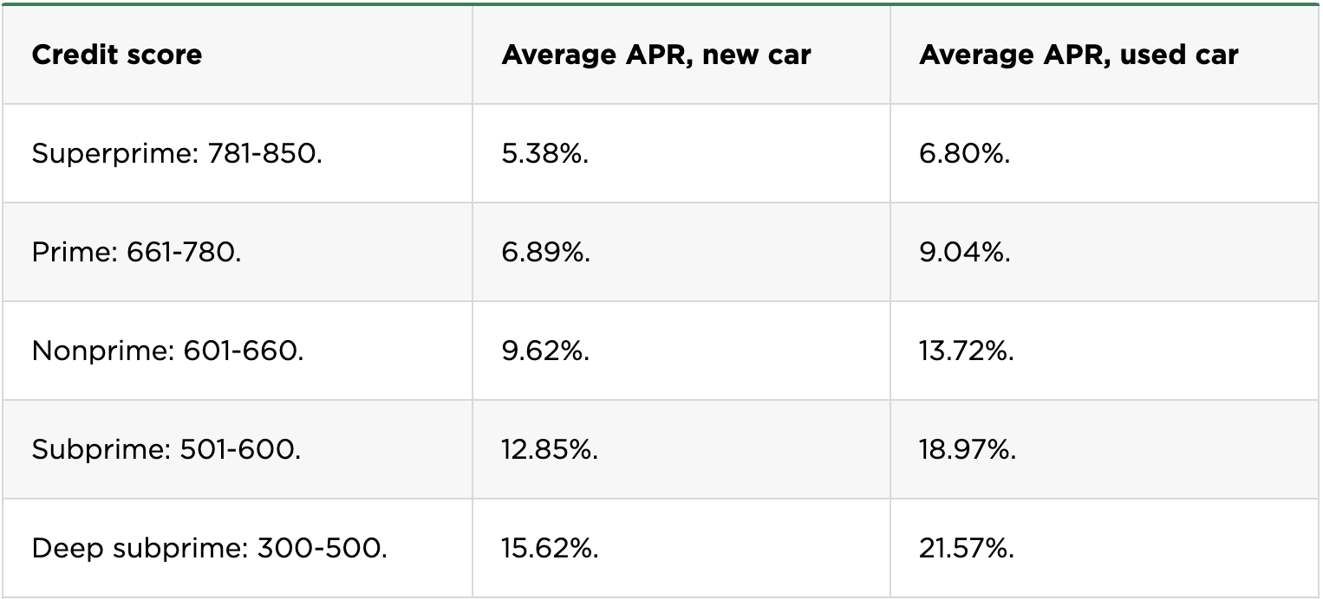
- Repossession Rates: The repossession rate for car loans is at 0.64%, suggesting a low rate of vehicle repossession.
Conclusion:
Auto loans are critical for purchasing automobiles, benefiting both the new and second-hand car markets. Creditworthiness and car value are assessed throughout the origination process, from application to approval. Effective loan service entails handling repayments, refinancing, and providing client support. Challenges such as economic downturns and loan complexity are addressed through flexible repayment plans, digital platforms, and predictive analytics for risk assessment, guaranteeing lenders can service consumers well while maintaining a strong loan portfolio.
Mortgage Loan Origination and Servicing:
Mortgage loans are necessary for homeownership, since they provide financing alternatives with fixed or adjustable interest rates. Conventional, FHA, and VA loans are among the many options available to meet the different demands and financial profiles of borrowers.
Origination Process:
- Application and Pre-Approval: Borrowers begin by filling out mortgage applications that include financial information, work history, and property specifications. The lender then evaluates creditworthiness, appraises the property, and verifies income and assets. Pre-approval is the next step, which gives borrowers an idea of their loan eligibility and terms.
- Loan Closing and Funding: All loan conditions, including interest rates, loan amounts, and repayment schedules, have been completed. Closing include signing loan paperwork, paying closing expenses, and establishing escrow accounts. The funds are subsequently disbursed to finalize the property acquisition or refinancing.
Servicing Process:
- Loan Repayment and Management: Monthly mortgage payments include principle, interest, property taxes, and insurance premiums. Escrow accounts handle tax and insurance monies, making budgeting easier. Borrowers can modify or refinance their mortgage terms in response to market circumstances or financial changes.
- Customer Service: Lenders offer complete support to borrowers, including assistance with mortgage queries, account administration, and financial difficulties. They also conduct foreclosure prevention strategies, providing specialized solutions to assist homeowners preserve their property and properly manage their mortgage commitments.
Challenges:
- Strong Regulatory regulations: Regulatory regulations establish rigorous guidelines on loan approval and servicing processes, requiring compliance to guarantee legal and ethical standards are followed.
- Risks from Interest Rate Fluctuations: Interest rate fluctuations offer risks to both lenders and borrowers by altering affordability and repayment capacities in response to economic conditions.
Solutions:
- Technological Advancements in Mortgage Processing: Technological innovations expedite mortgage processing and improve customer service by automating activities, increasing efficiency, and making information more accessible and clear to borrowers.
- Financial Education Programs: Lenders provide financial education programs to borrowers to assist them handle their homeownership duties successfully. These workshops are designed to increase financial literacy, budgeting skills, and comprehension of mortgage terms and obligations.
- Collaboration with Housing Counselling Agencies: Lenders work with housing counselling agencies to offer borrowers additional assistance and direction. These collaborations include tools such as counselling sessions, workshops, and specialized support to help borrowers manage obstacles and make educated decisions regarding homeownership.
Statistics:
- Average Mortgage Amount: The average mortgage loan amount in the United States is around $280,000.
- Interest Rate Trends: Mortgage interest rates vary but have generally been modest, ranging between 3% and 5% for fixed-rate mortgages.
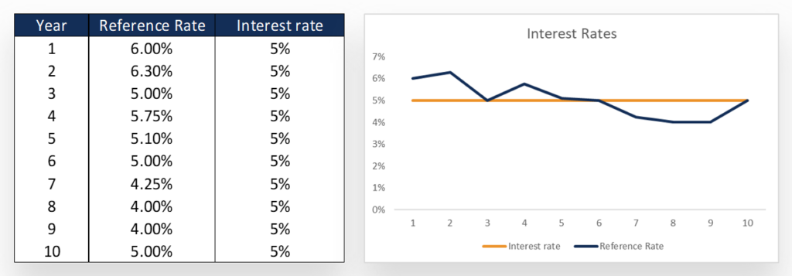
- Foreclosure Rates: Since the housing crisis, foreclosure rates have dropped dramatically, with the national foreclosure rate hovering around 0.27 percent.
Conclusion:
Mortgage loans provide specialized financing choices, allowing people to become homeowners. From application to closure, the procedure guarantees that loans match financial capabilities and property values. Effective servicing include monitoring repayments, escrow, and aiding with loan adjustments. Addressing regulatory compliance and interest rate issues through technology, borrower education, and collaboration with housing counselling organizations improves lender operations and borrower satisfaction.
Conclusion:
This extensive study explores the complexities of personal, auto, and mortgage loan origination and servicing in the United States. Understanding the procedures, data, and issues connected with each type of loan allows financial institutions to optimize lending operations, increase client happiness, and efficiently manage risks in today's changing financial world. Implementing new solutions and exploiting data-driven insights is critical for satisfying borrower demands and sustaining a loan portfolio.

